1. Install Laravel
2. npm install
3. install UI scaffolding or set environment in laravel and chose which one you want to install
   1. composer require laravel/ui (to install UI )
   2. php artisan ui help (to select the scaffolding preset type UI )
   3. php artisan ui vue (to install vue scaffolding )
4. npm install vue-router
5. “ and install other packages or plugins like vuetify if requires “
6. And then run
   1. php artisan serve
   2. npm run watch

What is vue.use()

Vue.use automatically prevents you from using the same plugin more than once, so calling it multiple times on the same plugin will install the plugin only once.

This is a root level component declaration, therefore, in your components, you do not require to declare something like following

Unnecessary if using Vue.use

import { Flag } from "vue-flag-icon"

export default {

components: { Flag }

}

What is export default

/*

The export statement is used when creating JavaScript modules to export live bindings to functions, objects, or primitive values from the module so they can be used by other programs with the import statement. The value of an imported binding is subject to change in the module that exports it. When a module updates the value of a binding that it exports, the update will be visible in its imported value.

There are two different types of export, **named** and **default**. You can have multiple named exports per module but only one default export.

*/

What is Popper.js used for?

A library used to manage poppers in web applications. Popper. js is a positioning engine, its purpose is **to calculate the position of an element to make it possible to position it near a given reference element**.

Webpack max.js

It actually convert the resources/app.js and resources /app.scss file from and into public js/app.js and css/app.scss

If we want to make any changes we have to do that in resources 🡺 js/app.js or css/app.scss, not in the public js or css file

And after making the changes we have to run the npm run dev and as a result of compilation the js and css file in public folder will be generated

If you made changes in public folder and then we compile the code in resources folder, that will replace the code in the public files. so made changes in resources that will reflect in public folder’s files

Vue Router

It helps us to hit a router and call a page

1. First import VueRouter from ‘vue-router’
2. then make it globally usable by Vue.user(VueRouter)
3. then take a routes array that contain the object of a path and component name i.e

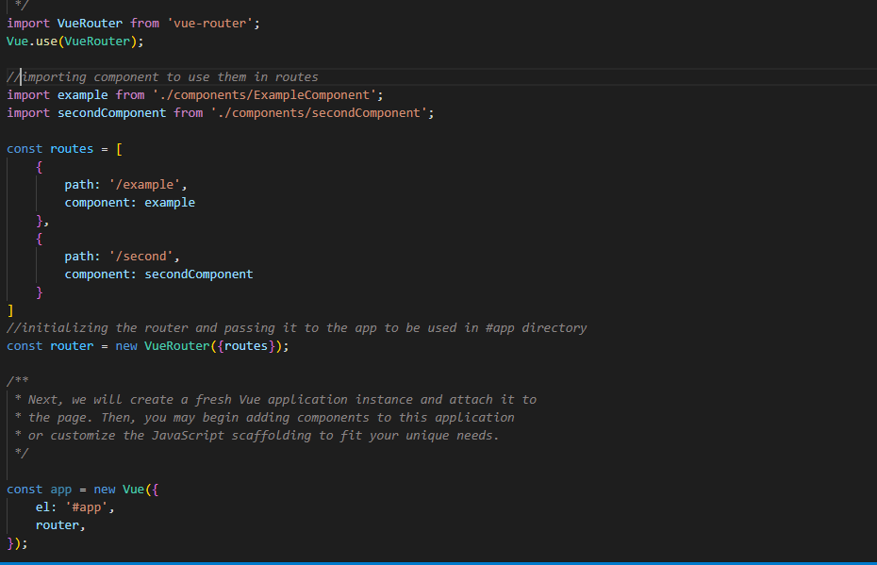

1. instantiate the router i.e const router = VueRouter({routes });
2. and pass it inside the app so it has to be usable inside div#app
3. ***remember that anything related to the vue must be inside the div#app, otherwise out of the limit of this div#app then vue code will not work***
4. to create a link use syntax like

<router-link to=”route_name_defined_in_routes->path”> String </router-link>

1. also add <router-view> </router-view> inside div#app so it return the view of the related link